**COAL LAB 6 (Lab Task)**

**Name: Adnan Hatim**

**Student ID = 24K-0656**

**CMP Example:**

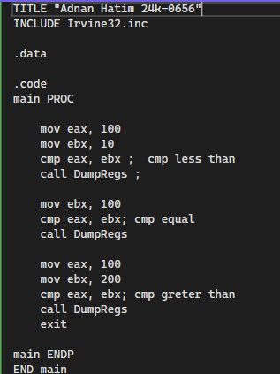

**JMP instruction:**

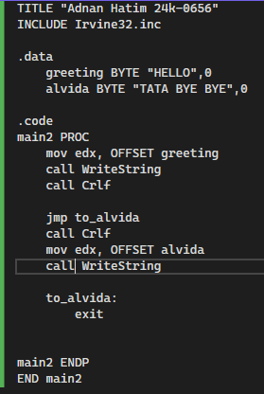

**Loop instruction:**

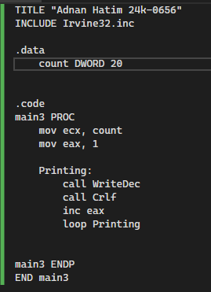

**Nested Loops:**

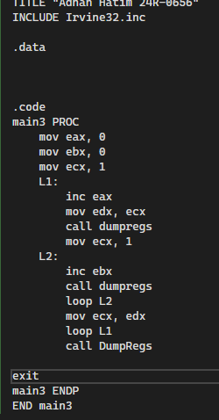

**READSTRING instruction**

